Registration Details

Registration fee per participant

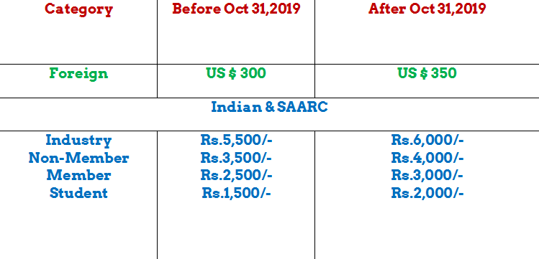

Registration fee includes cost of lunch, tea and coffee (on all the three days), conference materials and kit.

REGISTRATION FORM
(SMDTDS-2020)

International Conference on
Strategic Management, Decision Theory and Data Science January 4-6, 2020

Name:

  - Affiliation:

  - Designation:

  - Department:_

  - Address:

  - Telephone No. (O) Mobile:

E-mail:

  - Food Habit: Veg./ Non-Veg:

  - Registration Fee of Rs. Being paid in cash or Cheque(on Kolkata Bank)/Bank Draft

(No. ) Dated drawn in favour of Indian Association for Productivity, Quality & Reliability/ through NEFT (with transaction ID:

)

Dated: Signature:

